ARCHDIOCESE OF WESTMINSTER

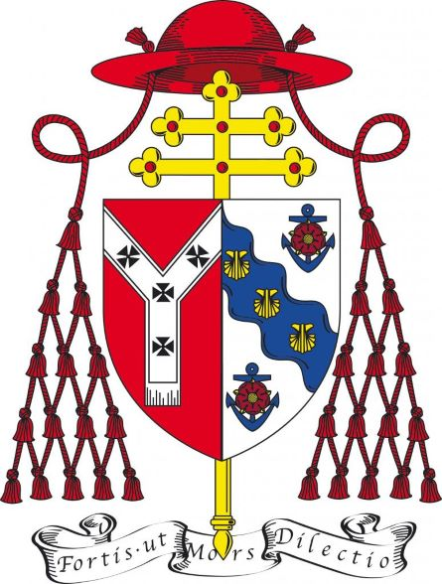

Westminster Diocesan Art and Architecture Committee Certificate

Permission to carry out

Works to a non-Listed Ecclesiastical Building

The Committee has considered this project and gives permission for the work, as described below, to be undertaken by the Parish.

Description of the works to be carried out:

1 Building (name) ……………………………………………………………..

2 Description ……………………………………………………………..

……………………………………………………………..

……………………………………………………………..

The Art and Architecture Committee of the Archdiocese of Westminster has considered the above application and approved it.

Date: Signed:

Chairman: Art and Architecture Committee

