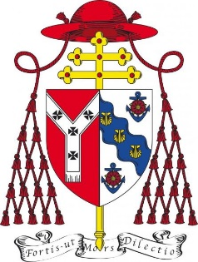 | Planning (Listed Buildings and Conservation Areas) Act 1990  The Ecclesiastical Exemption (Listed Buildings and Conservation Areas) Order 2010  Ecclesiastical Exemption Decree 1999 and canon 1276  Diocese Of Westminster

WESTMINSTER ART AND ARCHITECTURE COMMITTEE

APPROVAL CERTIFICATE

for an Application for Permission to carry out Works to a Listed Ecclesiastical Building

Part ‘A’ of this form should be completed by the applicant and then returned to the Chairman of the Art and Architecture Committee, Fr Peter Newby, together with full details of your project (as specified on page 5 of Application Process: for the refurbishment and reordering of churches and installation of artworks –which can be downloaded from the Diocesan website)

When the Committee is able to recommend the project to the Archbishop, this form will be signed and returned to you. The completed certificate should be attached to the application form for the submission of the project details to the Historic Churches Committee. (N.B. The Historic Churches Committee cannot proceed with your application until it has first been approved by the Art and Architecture Committee.)

PART ‘A’

1 Building (name) ………………..……………………………………………………………………………….

Status Cathedral Church / Other Parish Church / Other Church / Oratory / Private Chapel

Other (please specify)…………………………………………………………………..

Listing Grade I II* II

2 Works Proposed ………………..……………………………………………………………………………….

………………..……………………………………………………………………………………………………...

.………………..……………………………………………………………………………………………………..

………………..………………………………………………………………………………………………………

PART ‘B’

The Art and Architecture Committee of the Archdiocese of Westminster has considered the above application and has approved it.

Date: ___________________________ Signed: _______________________________________
Chairman of the Art and Architecture Committee

